|  |
| --- |
| **SOEN 6481**  **Software Systems Requirements Specification**  **Summer 2015**  Deliverable 1  Ticket Vending Machine used in Societe de Transport de Montreal  Team - D  Babak Boroujerdi Far  Dharani Kumar Palani  Dhruv Ohri  Naresh Kumar  Shu Liu  Xiaodong Li  Yang Liu |



Table of Contents

**1. A Brief Description of STM TVM 3**

**2. Context of Use Model for STM 4**

**3. Stakeholder Model 7**

**3.1. Mind Map of Stakeholders7**

**3.2. The Stakeholder Model8**

**3.3. Priority Table of Stakeholders10**

**4. Team Member-Responsibility Table 14**

**5. Tools Used for Deliverable 1 15**

**6. References 16**

# A Brief Description of STM TVM

A Ticket Vending Machine herein addressed as TVM in this document is a stationary human interaction system installed at locations to provide specific set of services to users. A Ticket Vending Machine assists in buying tickets/travel pass for a mode of transportation. The TVM is also prevalently used to assist in management of queue & priority of services in financial institutions, universities, insurance offices and customer helpdesks of several organisations. It saves the time, money and effort when compared to using human resources to provide the same services as above. It is highly available (99.99%) except for the preventive maintenance or power outages.

We have considered the ticket vending machine used in Societe de transport de Montreal (STM) for our project which is widely used in Montreal, Quebec, Canada. The STM serves the mobility needs of residents and visitors by offering an efficient public transit system. STM provides 1-trip pass, round-trip pass, evening passes, weekly, monthly pass and many others to customers depending on the requirements. Customers is provided with the options to select the kind of pass and the payment methods. The TVM used in STM is of particular interest for our team as it deals with several use cases like transaction (financial), security, identity verification and includes many stake holders when compared to the TVM’s used for other purposes.

STM offers the services in bilingual fashion in both French and English, by taking into the consideration of National and provincial interest. A registered user of STM is provided with an electronic card which allows him/her to recharge or buy tickets on demand using the TVM by choosing the method of payments. If the customer holds an OPUS Card, he/she can reuse it by making payment for the pass. This card can be recharged once a month or once in 4 months for its use. For the visitor or the citizens who does not have opus card, they can buy a printed pass. He/she can pay for more than one pass by selecting the number of passes. The TVM has built-in capability to ensure adequate security to prevent fraudulent usage by incorporating security checks with financial institutions for every transaction incurred. After the user makes payment and the bank verifies it, the user gets to collect the printed pass(s). However the paper printed tickets have time limitation. It must be used in one week. After that the tickets are invalid.

In every metro station, there is at least one Ticket Vending Machine. To protect the benefit of the customer, it has a very strong security and network stability. STM builds a stable network to make sure that thousands of users can use the system and rely on its service.

# Context of Use Model for STM

**Table 1: List of all factors and their details**

|  |  |
| --- | --- |
| **Type of Factor** | **Details** |
|  |  |
| 1. **User**    1. *Age*    2. *Knowledge*    3. *Skills*    4. *Experiences*    5. *Mental/Physical Attributes*    6. *Attention* | 5+  Basic knowledge about STM  User should know how to interact with a GUI and can read English or French  It would be helpful for the user if he/she has interacted with a similar kind of transportation  User should be mentally present and stable to interact the STM. The user who is even on wheelchair or whether he/she is blind can still operate STM  Complete |
|  |  |
| 1. **User Role**    1. *Registered*    2. *Non-Registered*    3. *Administrator* | Registered User can a STM Opus Charged Card to travel from one place to another without having to buy a ticket  Non-Registered User can also use the STM by buying the ticket from the STM TVM and then can travel. He has many options of selecting different kinds of passes depending on his priority.  Administrator can include network engineers who make sure it is 24/7 available and connected to the network, security engineers to make sure the security of the STM and the maintenance team for maintaining the STM TVM |
|  |  |
| 1. **User Task**    1. *Task-Specific Goal*    2. *Critically of Task*    3. *Frequency of Use*    4. *Dependency on Use*    5. *Duration of Use* | To complete the transaction for which the user is using the TVM like printing the ticket, printing the receipt  High importance because the user has to catch up with the transport to reach the destination in time  Users can buy the tickets as many times as he want, he/she is not restricted on the number of use per day  TVM should be connected with constant power supply and the TVM database  If the user is idle for more than 5 minutes, he would have to restart from the beginning |
|  |  |
| 1. **User Goal**    1. *Overall Goal of Software System Use*    2. *Critically of Goal* | Customer should complete the transaction of buying the ticket in an efficient manner  High |
|  |  |
| 1. **User Activity**    1. *Standing*    2. *Sitting* | STM is used in a standing position  User can be physically impaired(on a wheelchair) |
|  |  |
| 1. **Spatiotemporal**    1. *Time Zone*    2. *Current Time*    3. *Location* | Every transaction carried out have to be saved on the server database in standard time (For e.g. GMT)  Ticket is bought according to the local time  Available nearly at every STM station |
|  |  |
| 1. **Natural**    1. *Light* | Light should be adjustable |
|  |  |
| 1. **Technical Environment**    1. *Hardware*       1. *Screen Type*       2. *Keyboard Type*    2. *Network*       1. *Connectivity*       2. *Stability*    3. *System Software*       1. *System Software*       2. *Server*    4. *Reliability* | CPU interface with buttons on the side to select any option  Keys should be of appropriate size and material because of number of different users. Also OK, CANCEL and CLEAR should have the color GREEN, RED and Yellow on the keypad  It should be connected to the server 24/7 to keep the track of every ticket being printed  Should be stable enough to print many ticket in different places at the same time  A small-sized Operating Software for example Windows or any other preferable OS  Server should be working 24/7 using debit/credit cards and accepts cash as well. Every transaction should be recorded in the database  Downtime should be minimal as possible. Maintenance Team should supervise the STM and should fix it as soon as possible |
|  |  |
| 1. **Social Environment**    1. *Ethical Standards*    2. *Legal Constraints* | Should follow the Standard rules by Canadian Security and Safety Authority  Abide by rules and regulations by Transport Canada |
|  |  |

# 

# Stakeholder Model

* 1. **Mind Map of Stakeholders:**

Below is the image of the mind map which has been created after discussion and help from Teaching Assistant:

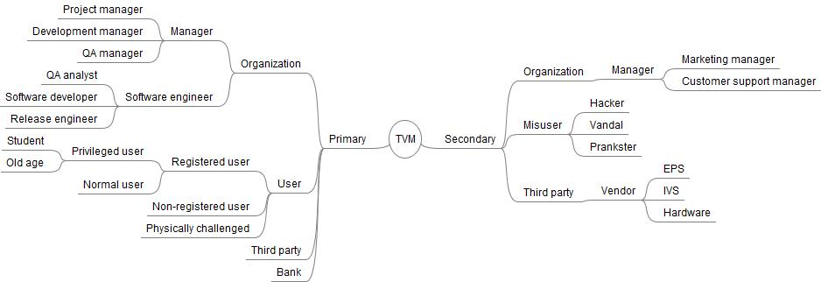

**Figure 1 – Stakeholder Model with end users and back office**

* 1. **The Stakeholder Model**

The stakeholder model is expressed in UML (Unified Modeling Language). A pragmatic approach to deal with expressing relationship among various stake holders is to present them in multiple diagrams in accordance with the interaction/relationship exhibited. The first diagram explains the relevance of end users in their relationship with other stakeholders of TVM. This UML diagram focuses on the various types of users and how they are involved with other stakeholders of TVM while using the TVM.

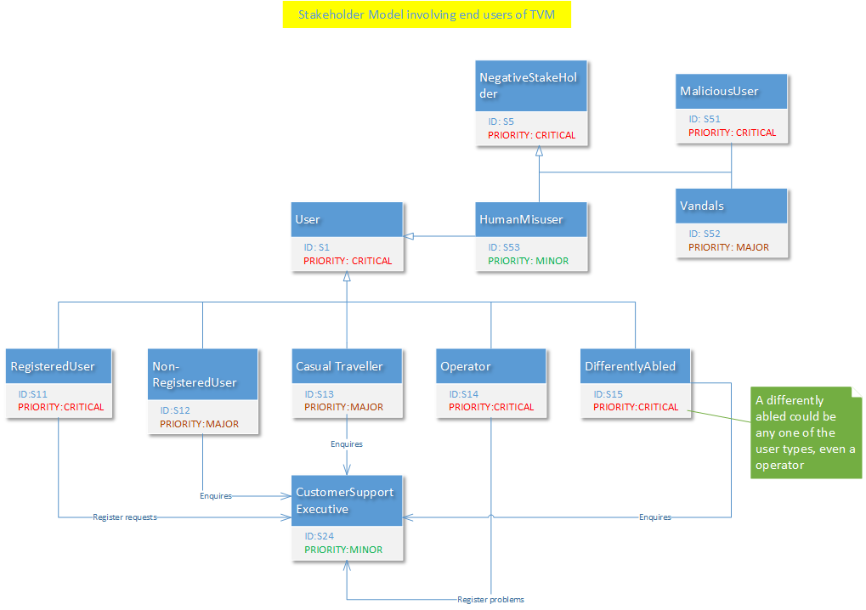

**Figure 2 – Stakeholder Model with end users and back office**

The figure 2 reveals how the different categories of user interact with a customer support executive. It is worth to mention about the negative stakeholders in the diagram, even though their interaction with other stake holders is quite limited or void. For example, human misuser is one classification of a negative stakeholder who could turn out a lawful legitimate user, but unable to access particular features of the TVM. Other categories of negative stakeholder involve vandals and malicious users who want to gain access or destroy the TVM for a personal pursuit.

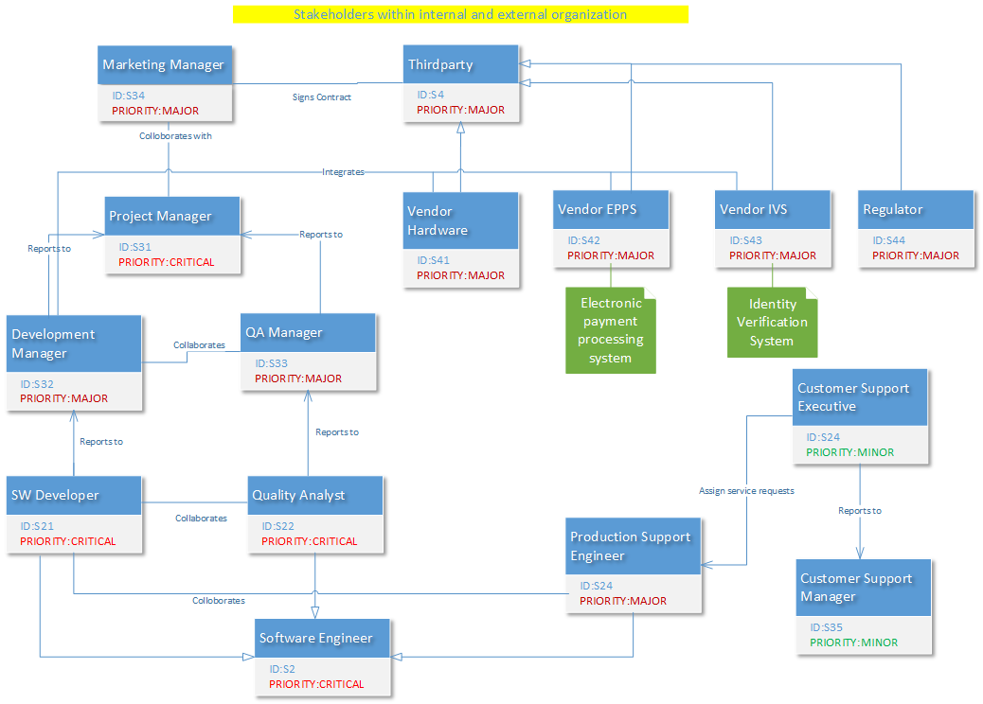

**Figure 3 – Stakeholder model for the organisation developing TVM**

Here the stakeholders are identified within the organisation which develops the software portion of the TVM. The stakeholders identified are typically found in a software development organization. A TVM is an end product comprised of both software and hardware components; there exists relationship between the critical stakeholders of the organization with third party stake holders like Hardware vendor, EPPS and EVS systems. The regulator belongs to government/ministry of Quebec is also an external stakeholder who has an influence on the outcome of the project and it is the responsibility of the project manager that the requirements and end product are in alignment with the regulatory constraints.

* 1. **Prioritization of Stakeholders:**

The scheme used for prioritization of stakeholders is derived by virtually placing the stake holders of the TVM in the **Influence-Importance** diagram. This has led to prioritize the stakeholders as Critical, Major and Minor. Further the stakeholders fall under two broad categories,

1.) Positive stake holders

2.) Negative stake holders.

Hence we have used two tables to list the stakeholders and their priorities.

**Table 2 – List of all positive stake holders and their priorities**

|  |  |  |  |
| --- | --- | --- | --- |
| **Serial Number** | **Stake Holder (ID)** | **Priority** | **Justification** |
| 1 | User (S1) | Critical | User is by far the most importance and influential stakeholder in the TVM project. Need no reasons |
| 2 | Registered (S11) | Critical | This user requires special attention from the TVM, as he reports lost card in which the STM has to lock the card to prevent misuse; balance will have to be transferred from old card to new one. |
| 3 | Non-Registered(S12) | Major | Here the registered card undergoes to checks for validity before issuing tickets; involves transaction to reload the card. |
| 4 | Casual Traveller(S13) | Major | Sometimes this user might get a ticket or get a one day or weekend pass. In such cases the system needs to ensure that the validity and trip rules. |
| 5 | Operator(S14) | Critical | He is a special user who does maintenance activity on the TVM and operates in a special mode. No other person should be able to perform this role, so tight security constraints & checks need to be in place. |
| 6 | Differently Abled(S15) | Critical | This user should be given at most importance as any system (software or hardware) should assist. This is also a regulator requirement. |
|  |  |  |  |
| 7 | Software Engineer(S2) | Critical | Engineers are the most critical stake holders as the end product is completely depended upon his understanding and effort. |
| 8 | Software Developer(S21) | Critical | The product, it’s quality, performance are all brain work of the software developer who is involved in the development of TVM software. |
| 9 | Quality Analyst(S22) | Critical | They ensure that quality is not compromised at any stage in the software development life cycle and places quality checks at every usable feature. |
| 10 | Production Support Engineer(S23) | Major | Though their contribution to the initial phases of SDLC is minor, they play a very important role when any issues are raised by the users or operator from the field. |
| 11 | Customer Support Executive(S24) | Minor | Addresses the queries from all types of users and registers issues specific to any user and forwards the complaints to the engineering team. |
|  |  |  |  |
| 12 | Manager(S3) | Major | They are important persons from the product point of view, but their influence on the project is constrained by their roles and responsibilities. |
| 13 | Project Manager(S31) | Critical | This stakeholder has utmost importance and influence on the outcome of the project. Gets full credit or blame for the outcome of the project. He sets the directions, methodology and vision for the project. |
| 14 | Development Manager(S32) | Major | Has more influence on the project life cycle either through the role or with his past experiences. Sometimes influence would be on daily or weekly activities. |
| 15 | QA Manager(S33) | Major | Importance on the project with respect to the software quality metrics and measurements. Though is not influential with respect to the specifications or development activities, he /she takes responsibility for quality loop holes. |
| 16 | Marketing Manager(S34) | Major | Drives the project outwards to the market, understands the market and external stakeholder needs and pass on to the engineering team. He ensures that project is abiding to regulatory requirements as well. |
| 17 | Customer Support Manager(S35) | Minor | Manages a set of customer support executives who addresses the specific needs of the user. |
|  |  |  |  |
| 18 | Third Party(S4) | Major | They are importance in the overall outcome of the project, not all third party stakeholders will have same influence on the project. |
| 19 | Vendor Hardware(S41) | Major | The vendor who provides the necessary equipments for the TVM. Any delays from this stakeholder will have an impact on the project however the influence on the project outcome is minimal. It is the responsibility of the marketing manager to identify the appropriate vendor. |
| 20 | Vendor EPPS(S42) | Major | The electronic payment processing system used to process payments to the registered and non-registered users who are issued tickets / reload of card from the respective user financial institution. |
| 21 | Vendor IVS(S43) | Major | The Identity verification system is used to verify the registered user identity to prevent misuse of their cards. |
| 22 | Regulator(S44) | Major | Regulator has major influence in the project, but not importance as he is a neutral body. The changes in regulatory requirements might have significant impact in the project. |

**Table 3 – List of all negative stake holders and their priorities**

|  |  |  |  |
| --- | --- | --- | --- |
| **Serial Number** | **Stake Holder(ID)** | **Priority** | **Justification** |
| 1 | Negative Stake Holder(S5) | Critical | The impact the system from safety and security aspects. As is the need of any software, security is one major aspect which cannot be compromised. |
| 2 | Malicious User(S51) | Critical | User who tries to operate TVM with a false/fake information/identity, for example using fake credit cards, fake transit cards to achieve not legitimate purpose.  The system need to identify and handle them with utmost care failing which will lead to financial lost to the company managing the TVM |
| 3 | Vandals(S52) | Minor | Users who can cause physical damage to the TVM.  Though this doesn't happen quite frequently, adequate protection should be in place to ensure that TVM cannot be damaged, by a single or small group of people.  But this is more of an environment and social problem, rather than a software problem by itself. They do not have much importance or influence on the software system. |
| 4 | Human Mis-user(S53) | Minor | A person who is trying to use TVM without the knowledge of how-to.  The software should be intelligent enough to identify such users and guide them to proper use. Proper error indications are required to make the novice user understand his mistakes. |

# 

# Team Member-Responsibility Table

|  |  |
| --- | --- |
| **Team Member** | **Details of Responsibilities** |
| Babak Boroujerdi Far | Added late in the team. Worked on Introduction(P1) and reviewing the work of other team members |
| Dharani Kumar Palani | Identifying the stakeholders(P3), Prioritizing the stakeholders(P3) and the creating the Use Case Model for stakeholders(P3) |
| Dhruv Ohri | Identifying the stakeholders(P3), prioritizing the stakeholders(P3) and creating mind map of stakeholders(P3) |
| Naresh Kumar | Management of Team, dividing of Tasks equally among all team members, Introduction(P1) and Context of Use Model(P2) |
| Shu Liu | Introduction(P1), Context of Use Model(P2) and Identifying the stakeholders(P3) |
| Xiaodong Li | Identifying the stakeholders(P3), prioritizing the stakeholders(P3) and creating mind map of stakeholders(P3) |
| Yang Liu | Identifying the stakeholders(P3), prioritizing the stakeholders(P3) and the creating the use case model for stakeholders(P3) |

P1: Problem 1

P2: Problem 2

P3: Problem 3

Link to the project wiki homepage:

[https://srs-soen-6481-d.wikispaces.com/home](https://soen6481fall14b.wikispaces.com/home)

# 

# Tools Used for Deliverable 1

Following are the tools we used for your communication, creating documents, generating diagrams for different tasks:

* Wikispaces
* Whatsapp
* Yahoo Mail
* FreeMind
* ArgoUML
* Poseidon
* Visio

We have used the course materials, notes, important links presented during the lectures and the meeting minutes with Teaching Assistant to complete the required tasks for Deliverable 1.

# 

# References

1. PANKAJ KAMTHAN. (2015). *UNDERSTANDING CONTEXT.* Available: http://users.encs.concordia.ca/~kamthan/courses/soen-6481/understanding_context.pdf.
2. PANKAJ KAMTHAN. (2015). *BRAINSTORMING AND MIND MAPPING.* Available: http://users.encs.concordia.ca/~kamthan/courses/soen-6481/brainstorming_mind_mapping.pdf.
3. PANKAJ KAMTHAN. (2015). *INTRODUCTION TO STAKEHOLDER MANAGEMENT.* Available: http://users.encs.concordia.ca/~kamthan/courses/soen-6481/stakeholder_management_introduction.pdf.
4. https://www.stm.info/en/info